CHAPTER III: RESEARCH METHODOLOGY

INTRODUCTION

This chapter is related to the presentation of the study and it contains the research methodology chosen to achieve this research study. It also consists of a system description, system architecture, system features, and system requirement specification.

System Description

Image-based Student Identification and Classification using Face Recognition are resourceful in giving an effective and reliable verification of student's accused over the existing image captured. it involves to know if image captured is student in the or Someone who is not and to avoid to mixed accused person (student) and a lawful.

The invigilator will scan the the image captured by the camera to know his/her class ,his/her ID and so and also facilitates to take decision quickest to know which person is accused or which one is lawful and also allow to reduce to happen wrong actions .

System Features

To get accused person's: This helps the invigilator if the camera captured full face to know if this face is part of Student and also know which class and what is his/her ID is.

To get Respected Person’s : This help invigilators a image captured partial of the face and not full face we will try to know this part of face which students is to be a passible to to become it get more students that is look after for this image .

System Requirement Specification

Software Requirement

Python: python is programming language to set up or program this project, Python is an interpreter, object-oriented, high-level programming language with dynamic semantics. Its dynamic typing and dynamic binding, along with its high-level built-in data structures, make it an appealing language for rapid application development and for usage as a scripting or glue language to join pre-existing components.
Because of its straightforward, simple syntax, Python prioritizes readability, which lowers the cost of program maintenance. Python's support for packages and modules promotes code reuse and program modularity. The large standard library and the Python interpreter are freely distributable and accessible for free on all major platforms in source or binary form.
Furthermore, Python is a dynamic programming language that works with a variety of paradigms:
- Procedural programming
- Object-oriented programming

Django: was introduced in 2003 when Adrian Holovaty and Simon Willison began using Python to build applications . The motivation for developing Django was the need to get applications done on a schedule of days or even hours. Two years after starting to create a web application framework, in 2005, it was released as open source. Today, 10 Django has several tens of thousands of users and development (Ghimire, 2020)
Django official Logo Because Django is a web application framework based on Python, you need Python to use it. Supported versions of Python are 2.6.5 and 2.7, but Django also offers experimental support from version 3.2.3 to version 3.3. Although Python includes a lightweight testing server, an Apache server and the mod_wsg package are required for the future Django-based website to function properly. Django officially supports PostgreSQL, MySQL, Oracle and SQLite databases(Ghimire, 2020).
Django also loosely applies MVC architecture. It becomes evident in Django, parts of the applications you created. In essence, models.py, views.py and urls.py, and the HTML template.Models.py contains a description of the information and provides functions for creating, retrieving, updating and deleting the data. View.py transmits the site content HTML template. The role of the urls.py file, in turn, is to configure which view file is called. With this structure and file functions, editing an application does not require editing many files, which in turn saves time (Ghimire, 2020).
NumPy: array is a data structure that efficiently stores and accesses multidimensional arrays17 (also known as tensors), and enables a wide variety of scientific computation. It consists of a pointer to memory, along with metadata used to interpret the data stored there, notably ‘data type’, ‘shape’ and ‘strides’ (Harris et al., 2020).

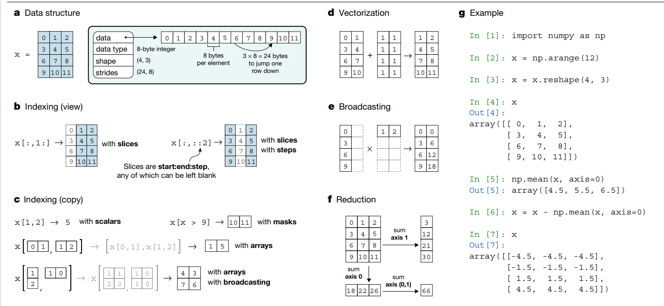
Figure 13.1 Numpy

OpenCV: is an open-source vision and machine learning software library written in Python. There is an extensive collection of reliable algorithms in the library. We'll take into consideration a few techniques for this case, such as face detection, face recognition, and similarity searches using a picture database. It can operate on a variety of operating systems and supports a wide range of programming languages. The other libraries will be employed in the proposed software system to gate a suitable development (Ismael & Irina, 2020)

Ghimire, D. (2020). Comparative study on Python web frameworks: Flask and Django.
Harris, C. R., Millman, K. J., Van Der Walt, S. J., Gommers, R., Virtanen, P., Cournapeau, D., Wieser, E., Taylor, J., Berg, S., Smith, N. J., & others. (2020). Array programming with NumPy. Nature, 585(7825), 357–362.
Ismael, K. D., & Irina, S. (2020). Face recognition using Viola-Jones depending on Python. Indonesian Journal of Electrical Engineering and Computer Science, 20(3), 1513–1521.

